Quarterly Report – Public Page

Date of Report: 2nd Quarterly Report, April 1, 2025
Contract Number: 693JK32410013POTA
Prepared for: DOT PHMSA
Project Title: Assess and Prevent Threats in Conversion or Repurposing Pipeline Systems
Prepared by: DNV
Contact Information: Greg Morris, greg.morris@dnv.com, 614-761-1214
Tara McMahan, tara.podnar.mcmahan@dnv.com, 614-761-1214
For quarterly period ending: March 31, 2025

1: Items Completed During this Quarterly Period:

No deliverables this period.

2: Items Not-Completed During this Quarterly Period:

Item # | Task # | Activity/Deliverable | Title | Federal Cost | Cost Share
1 | 1 | List of papers reviewed, summary of contribution to project, and 50% of the drafted language of the literature review | Interim Deliverable | 10,375 | 27,500

Project is approximately 1 week behind schedule. Interim Deliverable to be submitted by April 4, 2025.

3: Project Financial Tracking During this Quarterly Period:
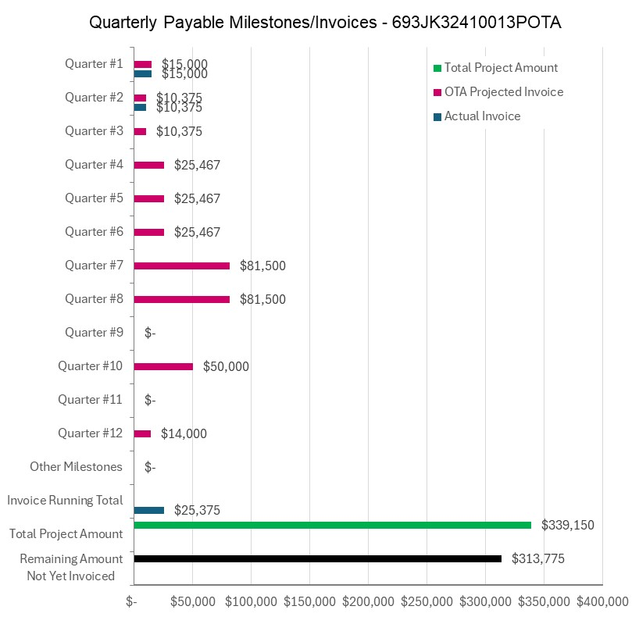

4: Project Technical Status –

DNV held the first quarterly TAP Meeting on March 27, 2005, to provide a status report on the project.

DNV informed the TAP that the list of references DNV has compiled and reviewed for the Task 1 literature review (a project deliverable) will be submitted to the TAP by April 4, and requests that the TAP indicate any noteworthy and relevant references that should be added.

DNV plans to provide the first 50% of the literature review text (an interim project deliverable) to TAP for review and comment by April 4, 2025.

Minutes of the Quarterly TAP meeting are posted to the project share site (PHMSA Repurposing Guidance Project - Home).

5: Project Schedule –

The project is approximately 1 week behind schedule. It is not anticipated that this delay will carry forward and impact the remaining project schedule.

